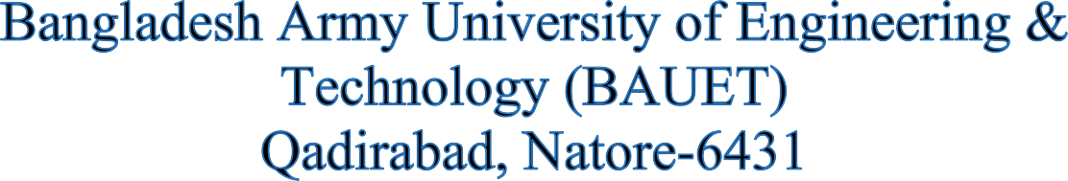



**Department of**

**Computer Science and Engineering (CSE)**

**Lab Report**

**Course Code : EEE-2266**

**Course Title : Electrical Drives and Instrumentation Sessional**

**Experiment No : 02**

**Experiment Name: Determine of Turn Ratio of Single-Phase Transformer.**

**Date of Experiment: 10/07/24**

**Date of Submission : 11/09/24**

# **SUBMITTED BY:**

Name : Md. Mueid Shahriar

ID : 0812220205101016

Batch : 16th

Year : 2nd

Semester : 2nd

Session : 2022-23

# **SUBMITTED TO:**

**Md. Mushfikur Rahman Khan**

Lecturer, Dept. of EEE,

BAUET.

**Al Hadit Moon**

Lecturer, Dept. of EEE,

BAUET.